
Conferencing & Special Event Services

In conjunction with


Is pleased to offer
Corporate Catering for any occasion

We come to your office or home with a complete cost effective
catering service for any sized event from 5 to 500!

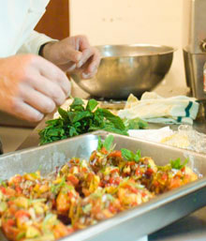

INTRODUCTION

Bon Appétit Catering…it’s how our company started.

We recognize the great power and importance of food. Food sustains not only our bodies but also our communities, environment and ultimately, our spirits. Food brings people together, creates a sense of place and feeling of kinship.

Today we continue to specialize in serving catered events keeping in mind our simple kitchen philosophy. We cook from scratch using fresh, authentic ingredients starting with foods in the simplest and most natural form. We purchase local and seasonal products and we make our food alive with flavor and nutrition to best serve all your catering needs including the small, quaint get-together, to the full banquet, or major productions serving hundreds of people for your theme extravaganza. Fine catering is the challenge; creativity is our response.
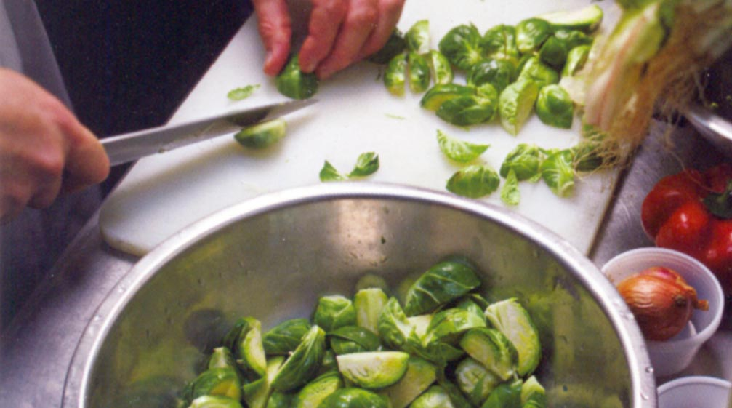
At Bon Appétit we are very proud of our catering service. Our hallmark is custom menu design and we are happy to create original menus for any occasion. You will find that we offer only the finest, freshest ingredients, prepared with creativity and passion. We care about our guests and about what they like, thus we customize every event to suit individual needs. We blend a tradition of fine service with creative planning and consistent event execution to bring satisfaction to our clients and customers every time.

This brochure is designed to simplify event planning and give you a look at our fresh contemporary menu and service selections. We are here to make your event everything it should be…….special.

We at Bon Appétit are pleased to offer this Catering Guide developed exclusively for Concordia University Conferencing and Event Services. Our goal, as always, is to provide exceptional service and the finest quality foods prepared with attentive care. Quite simply, we believe that meeting our customer’s needs is not enough: we want to exceed them.

This catering guide has been designed to assist you in planning a successful event whether it be a small coffee service or an extravagant dinner party. We have organized this guide to make the process as detail-oriented as possible while tempting you with our specialty menus and service options.
Above all, we want you to know we are at your service whatever your needs may be.

We’ll ask you to start by reviewing our Catering Guide in order to begin your planning process.
Then please give us a call and let us start working for you.

Concordia University
Conferencing and Event Services
(949) 854-8002 X 1719

Bon Appétit

Management Company

Planning Your Catered Event

Booking a catered event through Concordia University is an easy process... From the small coffee break to an extravaganza, at the office or at home, the process is designed to make it simple for our customers. We will work with you to plan the overall event which includes menu selection, service style, timing and any other details.

Concordia University, University Services (949) 854-8002 X 1719

University Services Conferencing & Events is your one stop contact in reserving catering for your event. In most cases, they can create the order for you and submit it to us for preparation based upon your requests. They will coordinate all service, setup, rentals, and delivery for you. Once the details have been discussed, a food service request form will be filled out, with a copy going to you confirming the specifics. This form is available in electronic format for your convenience.

If your event requires specialty items not listed on the menu, special theme set ups, or additional servers, we will arrange to have a member of the Bon Appétit staff visit in person to assist in planning your catering needs.

Bon Appétit Catering

Bon Appétit will assist in the planning of your event which includes the type of event, menu selections and desired services. At this point we will offer the menu planning section from this guide to aid in determining what type of food and beverage service you would like for the event. Please note: all events are customized to your specific needs and the guide is only a base for developing your menu selections.

Guarantees
When arranging for a catered event, attendance must be specified five (5) business days in advance of the event. For weekend events the final guest count must be confirmed on Tuesday before the event.

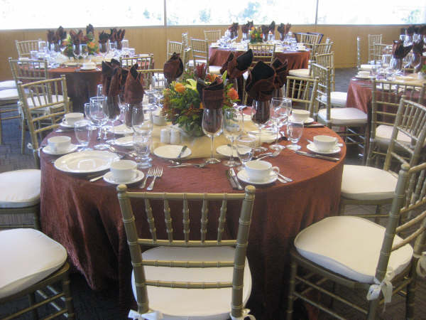

SPECIALTY SERVICES

Because catering and service demands vary, we offer additional services to complete your function. Specialty services are priced in addition to your event package.

- Custom Floral Arrangements: (estimates provided on request) Flowers add a special touch to any event. From simple bud vases to dramatic centerpieces we are happy to work with you and local select florists on creating a package to fit your needs.

- Décor Arrangements: (estimates provided on request) Many catered events turn from the ordinary to the spectacular with the addition of specialized décor. Our creative experts will be happy to suggest the right touches or the best props to make this happen for your event. We have knowledgeable consultants who can provide theatre style props, backgrounds or festive balloons to make your event spectacular.

- Specialty Linens: (estimates provided on request) If we don’t have the right colors for you, we’ll find them. Specialty tablecloths and napkins can be a nice touch for dinner and theme events.

- Facility & Set Up Coordination: Arranged and priced through University Services 949-854-8002 x1719. Bon Appétit coordinates all delivery, set-up and equipment return.

- Additional Service Staff: Additional staff is available for events that you feel require VIP treatment.

- There will be a delivery Charge –$20.00 for the first 10 miles and addition $10.00 for each 10 miles.
Bon Appétit Service Staff Minimum of 4 hours per person $16.50 per hour

♦ There will be an 18% Gratuity added to the total billing (not including sales tax).

All orders include paper and plastic utensils. Top quality black plastic plates add $.50,
fine china add $1.50 per setting and additional labor.

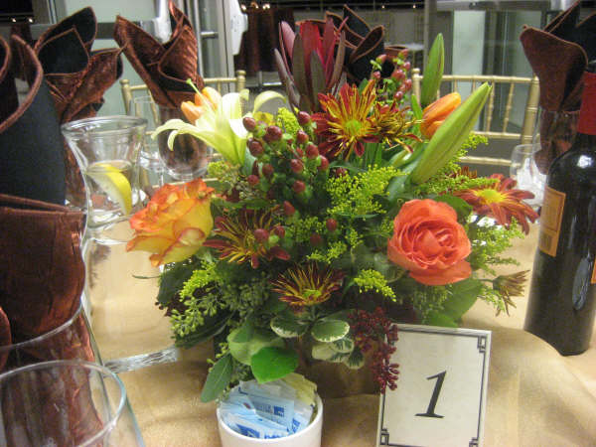

BREAKFAST SELECTIONS
$1.75 - $7.95 per person

The Coffee Break

Freshly brewed regular and decaffeinated coffee with a selection of

International teas.

The Mini Continental

Freshly brewed regular and decaffeinated coffee, international teas,
orange juice and freshly baked pastries.

The Continental

Freshly brewed regular and decaffeinated coffee, international teas,
orange juice, freshly baked pastries and seasonal fresh fruit.

The Bagel Continental
Seasonal fresh fruit, an assortment of freshly baked, pre-sliced
bagels, cream cheese, assorted juices, coffee and tea service.
Add a smoked salmon platter.

Country Breakfast Buffet
Scrambled eggs, bacon & sausage links, home fries or hash browns,
freshly baked breakfast pastries, coffee, decaffeinated coffee,
International teas and orange juice.

Breakfast- A La Carte (build your own) $1.25 - $3.25 per person

Assorted Bakery

Variety of Freshly Baked Muffins, Breads & Coffeecake
Scones with Preserves
Bagels with Cream Cheese
Mini Assorted Danish & Croissants
Seasonal Fresh Fruit Platter or Bowl
Whole Fresh Fruit
Creamy Fruit or Plain Yogurt
Canned Soda
Bottled Water
Freshly Baked Cookies or Brownies
Fruit Juice (orange, cranberry, apple)
Iced Tea, Lemonade or Fruit Punch
Flavored Coffees



Deli Sandwiches
Sandwich selections include potato chips, “dessert of the day” & a beverage.
(Minimum of 5 orders)
$8.00 - $9.45 per person
Traditional American Deli Sandwich

Your choice of fresh roasted turkey breast, roasted top round of beef or ham with American cheese, lettuce & tomato on your choice of sliced breads, croissant or French roll.

The Italian

Sliced ham, salami, provolone cheese with lettuce, tomato, red onion & extra virgin olive oil and Italian vinaigrette on a soft French roll.

The Concordian

Freshly made white meat chicken salad, egg salad or tuna salad on a croissant with

lettuce and tomato.

Vegetarian Gourmet
Grilled eggplant, roasted red and yellow bell peppers, mozzarella cheese & basil aioli on multi-grain bread.

Lemon Herbed Chicken Breast Sandwich

Chilled breast of chicken, roasted red peppers and provolone cheese with plum tomatoes, romaine lettuce, and herbed mayonnaise on a wheat bun.

Teriyaki Chicken Sandwich
Grilled teriyaki marinated chicken breast served with lettuce, tomato, and roasted garlic mayonnaise on a seeded roll.

The Greek
Feta cheese, tomato, black olives, green pepper, cucumber & red onion in a pita pocket with Greek dressing.
Add Grilled Sliced Chicken Breast

Turkey, Bacon, Lettuce & Tomato Wrap

Fresh roasted turkey, bacon, crisp romaine and diced tomato wrapped in a tortilla.

Chicken Caesar Salad Wrap

Romaine lettuce with grilled chicken strips, freshly baked croutons, parmesan cheese & Caesar dressing wrapped in a tortilla.

BBQ Steak Wrap
BBQ grilled steak with tomato, red onion, olives, mixed greens, chili ranch dressing and avocado spread in a colorful tortilla.

Chinese Chicken Wrap
Tender pieces of teriyaki style chicken gently tossed with an Asian ginger sesame dressing and crisp Asian vegetables.

Add a side salad of pasta, coleslaw or potato $2.25per person
Add a side salad of garden greens $2.25 per person
Add a side specialty salad $2.75 per person

Garden Green Salads
Salad selections include fresh baked rolls & butter, fresh baked cookies and a beverage.
(Minimum of 5 orders)
$7.45 - $8.75 per person

Almond Chicken Salad

Freshly made white meat chicken salad with toasted sliced almonds on a bed of mixed greens accompanied by seasonal fresh cut fruit and banana bread.

Antipasto Salad

Sliced ham, salami, pepperoni, provolone cheese on a bed of crisp greens accompanied by black olives, green peppers, red onion, pepperoncini and topped with Italian vinaigrette.

Classic Chicken Caesar Salad

Hearts of romaine lettuce tossed in our own creamy Caesar dressing with grilled strips of chicken, garlic herbed croutons, shredded parmesan cheese.

Chinese Chicken Salad
Teriyaki marinated chicken, red cabbage, green onion, Mandarin oranges, water chestnuts, sesame seeds & Chinese noodles over a bed of field greens with an Asian ginger dressing.

Fiesta Taco Salad

Seasoned ground beef or chicken served in a flour tortilla shell filled with a refried beans, topped with a bed of greens, shredded jack and cheddar cheeses, black olives, diced tomatoes, fresh pico de gallo served with tortilla strips and creamy salsa dressing.

Garden Greens

Crisp garden greens with tomatoes, sliced cucumber, shredded carrot, sweet red onion and fresh baked croutons served with your choice of dressing.

Hawaiian Chicken Salad
Grilled Chicken breast served atop soba noodles, grilled pineapple, bean sprouts, shredded carrot, nappa cabbage, fresh cilantro, crispy wontons, chopped salted peanuts topped with a ginger lime dressing.

The Greek
Feta cheese, tomato, black olives, green pepper, cucumber & red onion on a bed of crisp romaine & baby spinach tossed with a red wine vinaigrette. Served w/ toasted pita chips.
Add Marinated Grilled Chicken Breast

Ranch Chicken Breast Salad

Seasoned and grilled chicken breast, black beans, sweet corn, diced red peppers, shredded jack and cheddar cheeses over a bed of crisp field greens served with a spicy ranch dressing.

Spinach Salad
Tender baby spinach leaves topped with diced bacon, red onion, sliced hard boiled egg, tomatoes, mushrooms and Mandarin oranges with creamy whole grain Dijon dressing.

Homemade Soups
(48 hour notice required)
(Minimum of 8 orders)
Choose one of the classic kettled soups, served piping hot with rolls & butter. $4.75 per person

New England Clam Chowder Chicken Tortilla Soup
Split Pea & Ham Soup Vegetarian Chili

Served in a hollowed sourdough bread bowl $6.95 per person

Theme Buffets
All buffets are served with iced tea, assorted sodas & coffee.
(Minimum of 16 orders)
$7.25 - $12.75 per person
New York Deli Style Buffet
Honey-cured ham, roasted turkey breast, roast beef, sliced domestic cheeses, leaf lettuce, tomatoes, dill pickles, deli style potato salad, macaroni salad, mustard, mayonnaise, a variety of breads and an assortment of cookies & brownies.

Italian Style Buffet

Choose Two: Stuffed shells, beef or vegetable lasagna, cheese ravioli or chicken picatta. Served with our classic Caesar salad with hearts of romaine lettuce, creamy Caesar dressing, garlic herbed croutons, shredded parmesan cheese, garlic bread and your choice of tiramisu or creamy cheesecake.

Santa Maria BBQ
Choose two: BBQ spare ribs, chicken breast, or marinated tri-tip served with coleslaw, roasted corn on the cob, ranch style baked beans, Texas toast, pico de gallo and your choice of fruit cobbler or apple pie.

Mexican Fiesta
Choose two: Carne asada tacos, chicken enchiladas, bean & cheese burrito or chili verde. Served with Spanish rice, refried beans, freshly made salsa and pico de gallo, sour cream, shredded cheddar & jack cheeses and your choice of churros or caramel flan.

Chinese Take Out
Choose two: Kung Pao chicken, beef & broccoli, sweet & sour pork, garlic pan fried noodles with vegetables & tofu. Served with sautéed green beans or mixed vegetable stir-fry, vegetable fried rice, sweet orange sections, almond cookies & fortune cookies.

Cookout
All beef hot dogs, all beef hamburgers (garden burgers available on request) with sliced domestic cheeses, lettuce leaf, sliced tomatoes, sliced onions, pickle wedges. Served with baked beans, corn on the cob, crisp garden green salad, and your choice of potato salad, macaroni salad or coleslaw and cookies or brownies for dessert.
BBQ Chicken breasts also available

Pick A Pizza Party
Choose from a variety of pizza toppings including cheese, pepperoni, sausage, honey cured smoked ham, fresh tomato, basil, pineapple, mushroom, black olive, onion &, bell peppers. Served with garden green salad, choice of dressings and cookies or brownies for dessert...
(Serving size is based on 2 slices per person)

Gourmet Pizza Selections available on request.

Add a specialty dessert $1.50-$2.75 per person extra

SPECIALTY BUFFETS
Includes your choice of salad selections, an entrée, appropriate starch and vegetable du jour, fresh baked rolls, butter, dessert, coffee & soda or iced tea.
(Minimum of 12 orders)
$11.45 - $16.45 per person
Salad Selections

Caesar Salad Greek Salad Garden Field Greens Salad
Seasonal Fruit Bowl Tomato Salad

Pasta Selections
Capellini al Pomodoro (angel hair pasta with fresh tomato & basil)
Penne Puttanesca (olives, capers, garlic, shallots & tomato in a white wine sauce)
Traditional Spaghetti & Meatballs with a marinara sauce
Spinach Fettuccini with Italian sausage & marinara sauce
Lasagna Florentine
Smoked Salmon Penne Pasta in a light tomato cream sauce

Seafood Selections*
Grilled Wild Salmon with a shitake vinaigrette $ Market priced
Grilled Ahi Tuna with black bean sauce $ Market priced
Lime-cilantro Marinated Mahi Mahi w/ mango salsa $ Market priced
Salted Pacific Halibut with tomato caper sauce $ Market priced

Poultry Selections
Sautéed Breast of Chicken with a port cream sauce
Cilantro Lime Chicken with a pico de gallo salsa
Pesto Chicken with sun-dried tomatoes, prosciutto & broccoli
Chicken Marsala with wild mushroom mélange

Beef & Pork Selections
Cranberry Glazed & Roasted Pork Loin
Beef Burgundy
Teriyaki Beef Stir-Fry

Dessert Selections
Apple Crisp Chocolate Mousse Cake Warm Berry Cobbler

Concordia Cream Puffs Lemon Meringue Pie Assorted Brownies & Cookies

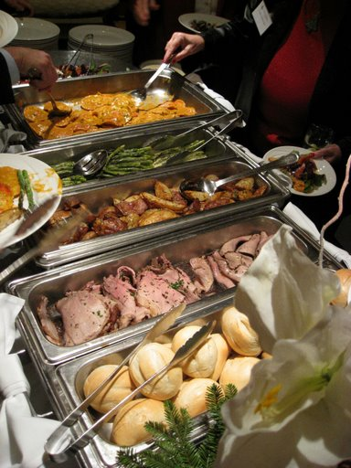
*Seafood availability subject to compliance with the Monterey Bay Aquarium Seafood Watch.
DINNER ENTREES
All dinners are served with choice of salad, entrée, freshly baked roll, butter, choice of specialty dessert, coffee & tea. Price is set for buffet service; seated service available upon request.
(Minimum of 12 orders)
$15.45 - $18.95 per person
Fresh Chilled Salads

Garden field greens salad with ranch dressing

Tossed Caesar salad
Hearts of romaine with plum tomatoes, fresh mozzarella & balsamic vinaigrette
Red leaf lettuce with warm goat cheese, toasted pine nuts and red wine vinaigrette

Poultry

Chicken Picatta

Boneless breast of chicken with white wine, caper, lemon sauce served over linguini pasta with artichoke hearts and seasonal vegetables.

Grilled or Baked Chicken Breast
Prepared to your preference with Indian curry, Cajun blackened or apricot glazed served with complimentary side dishes.

Pesto Stuffed Breast of Chicken
Baked boneless breast of chicken stuffed with basil pesto, sun-dried tomato puree and mozzarella cheese, and then topped with a pesto cream served over a bed of linguini with seasonal baby vegetables.

Beef & Pork

Roast Prime Rib of Beef $ Market Price
With creamed horseradish and au jus served medium rare, with garlic mashed potatoes and seasonal vegetable.

Filet Mignon $ Market Price
Broiled to medium, topped with wild mushroom demi-glace served with garlic roasted red
potatoes and seasonal fresh vegetable.

Roasted Pork Tenderloin
Roasted pork medallions topped with a cognac green pepper sauce served with wild mushroom & parsley orzo and seasonal fresh vegetable.

Dessert Selections
Specialty Cheesecake Fresh Fruit Tart Apple Alsace Tart
Chocolate Ganache Torte Cappuccino Flan Amaretto Rice Pudding
With raspberry sauce with a raisin butter glaze
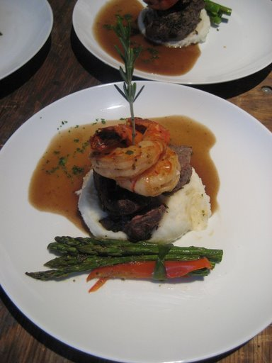 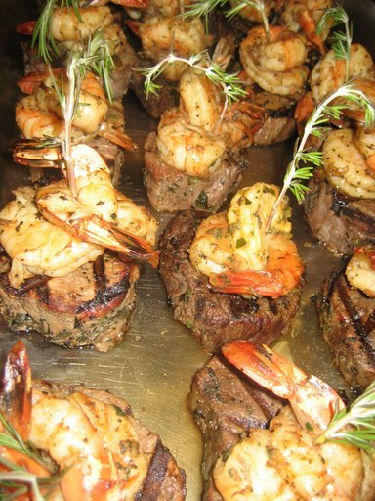

DINNER ENTREES (Continued)
All dinners are served with choice of salad, entrée, freshly baked roll, butter, choice of specialty dessert, coffee & tea. Price is set for buffet service; seated service available upon request.
(Minimum of 12 orders)
$13.45 - $18.95 per person
Fresh Chilled Salads

Garden field greens salad with ranch dressing

Tossed Caesar salad
Hearts of romaine with plum tomatoes, fresh mozzarella & balsamic vinaigrette
Red leaf lettuce with warm goat cheese, toasted pine nuts and red wine vinaigrette

Seafood*

Pacific Halibut
Hazelnut encrusted halibut served with a whole grain Dijon cream sauce accompanied by wild rice pilaf and seasonal steamed vegetables.

Wild Salmon Medallions
Baked wild salmon accompanied by crispy potato pancakes, au gratin baby vegetables and topped with a Chipolte sauce.

Pasta Pescador
Linguini with butter-flied shrimp, bay scallops, mussels & clams in a spicy tomato sauce.

Poached White Seabass Market Price
With a roasted vegetable sauce accompanied by jasmine rice & baby seasonal vegetables.

Pasta/Vegetarian

Fettuccini Primavera
Pasta sautéed in virgin olive oil and fresh garlic with fresh tomato, mushrooms, zucchini, broccoli florets and baby carrots.

Eggplant Parmesan
Breaded eggplant slices layered with mozzarella cheese and marinara sauce topped with freshly grated parmesan cheese served with spaghetti & marinara and garlic sautéed fresh vegetables.

Vegan Bean Cakes or Vegan Tofu Cakes
Seasoned bean cake served atop a bed of sautéed spinach barley pilaf with pear tomatoes and garlic.

Vegetable Polenta Tower
Grilled zucchini, tomato, red onion & eggplant atop a fresh baked polenta cake garnished with a tomato basil sauce.

Dessert Selections
Specialty Cheesecake Fresh Fruit Tart Apple Alsace Tart

Chocolate Ganache Torte Cappuccino Flan Amaretto Rice Pudding
With raspberry sauce with a raisin butter glaze

*Seafood availability subject to compliance with the Monterey Bay Aquarium Seafood Watch.

HORS D’OEUVRES
A la carte items (select one item and we’ll prepare 3 pieces per person). Plan to serve six pieces per person for a pre-dinner reception event and nine pieces per person for a reception only event.
(Minimum of 25 orders)

Garden Vegetable Platter with spinach dip $3.50per person
Warm Artichoke Parmesan Dip served with gourmet crackers
Red Potatoes topped with crème fraiche & fresh garden herbs
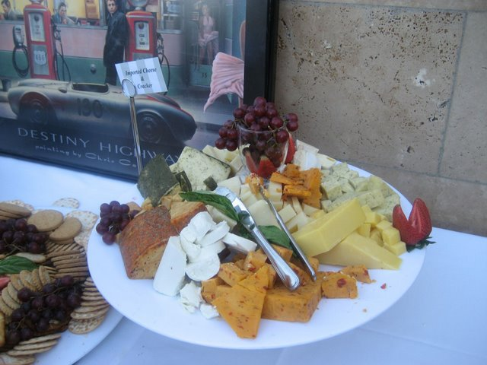
Spring rolls: vegetable or shrimp with a peanut dipping sauce
Vegetable Pot Stickers with a hoisin dipping sauce
Spanikopita: baked Phyllo filled with spinach & feta cheese
Parmesan & Herb Stuffed Baked Button Mushrooms
Lightly Battered Zucchini served with ranch dip
Tender Buffalo Wings in a zesty sauce served with bleu cheese dressing
Swedish Sweet & Sour Meatballs
Chicken Tenders with honey mustard, bbq sauce or house ranch dressing
Curried Chicken Pinwheels
Sun-dried Tomato, Basil and Cream Cheese Pinwheels

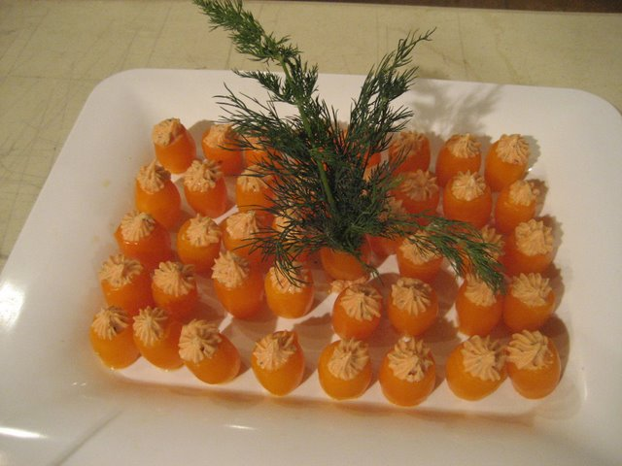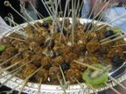

Chicken Satay: Baked chicken skewer served with a peanut dipping sauce $4.25per person
Teriyaki Beef Skewers
Baked Brie in Pastry
Smoked Salmon on pumpernickel crostini
Tomato & Basil Bruchetta
Prosciutto Wrapped Melon
Bacon wrapped dates stuffed with whole almonds
Garlic Herbed Scampi on crostini
Filet Mignon & Horseradish on baguette toast
Stuffed Mushroom Caps
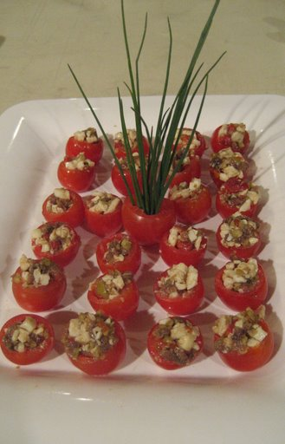

SWEET & SAVORY SNACKS
$1.25 - $4.50 per person
Assorted Sodas
Assorted sodas with ice and cups.

Assorted Cookies, Brownies, or Bar Cookies

Assorted Cake, Pastry, Cream Puffs and Bar Cookies

Cookies & Coffee
Freshly brewed coffee, decaffeinated and a selection of freshly baked cookies or brownies.

Gourmet Desserts
Customized per order including specialty tortes, tarts, cheesecakes, mousses and more.

Chocolate Covered Tuxedo Strawberries
Dark & white chocolate dipped fresh strawberries. (2 berries per serving.)

Ice Cream Social
Make your own ice cream sundae with vanilla or chocolate ice cream, chocolate syrup, chopped peanuts, chocolate chips, cookie crumbs and gummy bears.

Make It A Float
Your choice of vanilla ice cream and cola or root beer for a fabulous float or vanilla ice cream with orange soda for a creamsicle.

Assorted Packaged Snacks
Chips, popcorn, pretzels, cereal bars, corn nuts, peanuts and candy.

Potato Chips and French Onion Dip

Tortilla Chips & Freshly Made Roasted Salsa or Pico de Gallo

Hot Pretzels
Salted or unsalted pretzels served warm with yellow mustard & cheese sauce.

Cheese & Crackers
Domestic cheese tray served with sliced apple and gourmet crackers.

Gourmet Imported Cheese & Baguette
An array of imported cheeses including Stilton, smoked gouda and muenster served with French baguette slices and plump grape clusters.

Traditional Vegetable Platter
Crunchy vegetable platter with ranch dip.
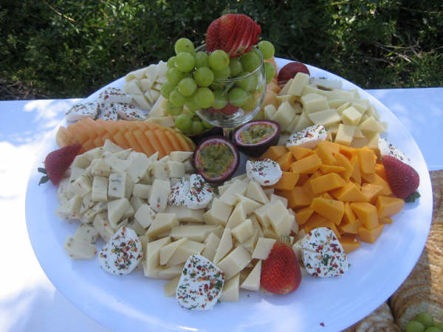
ASSORTED BEVERAGES
$1.25 - $3.75 per person

Kona Coffee (regular or decaf)
Flavored Coffee
International Tea Selection with Hot Water
Assorted Juices (orange, cranberry & apple)

Iced Tea (Black or Tropical)
Lemonade or Fruit Punch
Cranberry or Orange Spritzer
Sparkling Apple Cider
Hot Apple Cider

Canned Sodas
Bottle Waters
Fresh Specialty Juices

Assorted Red & White Wines (unlimited) $6.50 per person
Special Select Wines $ Market Price
Domestic Beer (unlimited) $6.25 per person
Wine Coolers (each) $2.75 per person
Coffee Supplies

Kona Coffee (regular or decaf)(7 oz)with filters $4.50 per bag
Variety of Flavored Coffee with filters $2.75 per bag
12 oz foam or paper cups (50 ct) $4.00 per sleeve
Sugar or Non-dairy creamer $2.75 per canister
Stir-sticks $2.25 per box
Black Tea or Herbal Tea Bags $4.50 per box
Half & Half $2.50 per quart

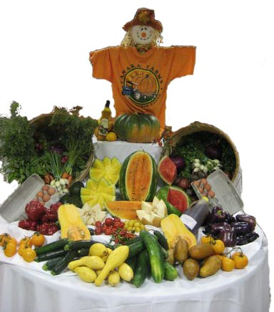

ADDITIONAL TOUCHES

White Linen Table Cloths $7.50 each
(Service tables set with complimentary linens)

Linen Table Cloths (special color or round in shape) $15.00 each
Linen Napkins in an assortment of colors $ 1.50 each

Flower Arrangements Market Price
We’ll help with the dimensional needs and source the arrangements to meet your budget.

Service Staff (available upon request)
Minimum of 4 hours per person $18.00 per hour

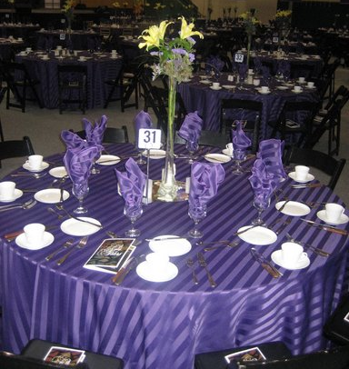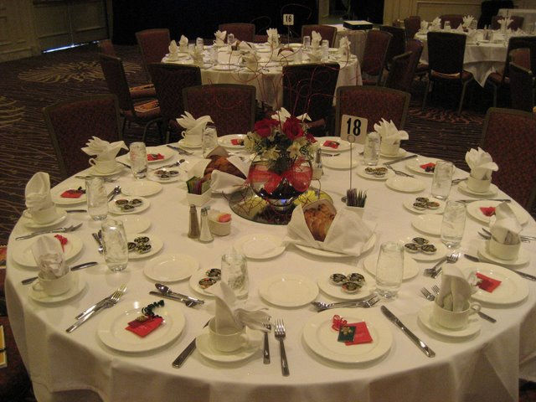

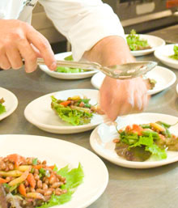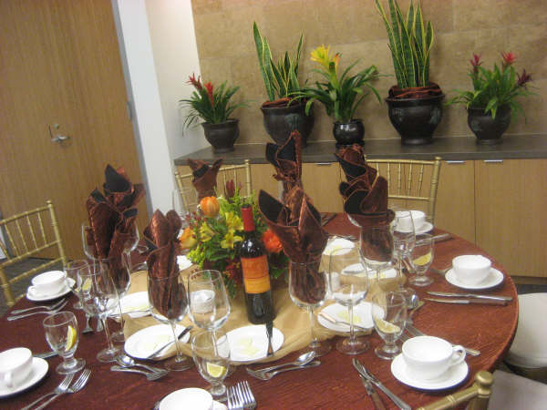

Copyright© 2009 Concordia University Irvine

