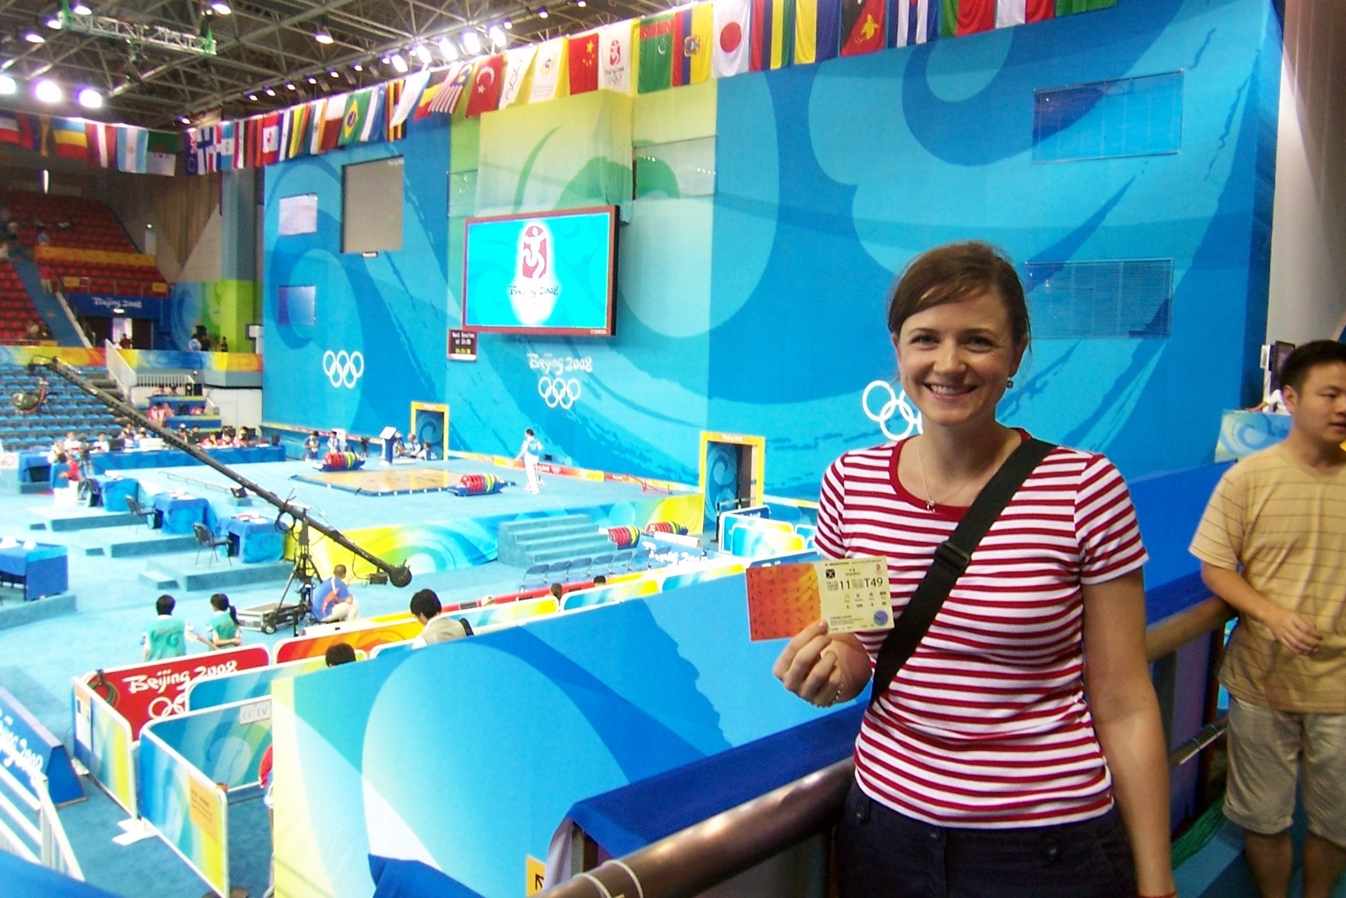
Christine Palowitch MAIS ’07 graduate (at Beijing Olympic Games venue)



"I would absolutely recommend the Concordia program if you want to travel, work and live abroad, in addition to working towards a Master's degree by relating your online classes to what you're seeing, breathing and feeling in China. I really enjoyed teaching in China, I worked for Scholastic, which has English language centers for children in Shanghai. I taught on the weekends, which can be intense, but then I had most of the week free to do homework, get to know the city and travel around China.
I had only taught a little bit before teaching in China and found it to be a great environment to learn from other foreigners and the local Chinese staff. And the students are adorable! Now, I'm working for Scholastic as the teacher trainer, training new and current teachers and helping to make their jobs as easy as possible. It's challenging to make all the different parts of your life here work, but that's what makes life here interesting and satisfying.
Right now, China is unlike any other place on Earth. It is growing and changing beneath my feet and every time I step out of my apartment in the middle of the city. It is becoming a modern, more Western place, but it still has its China quirks. You'll have good China days, when everything goes right and you feel on top of the world; and then there are bad China days when you want to stay in your room or search out Western food and fellow program friends for a big taste of home. These days come and go, but when you get through those bad China days (and really bad days happen in every corner of every country) you'll be happy you're still in China to realize you have no idea what the next day will bring to you.
The Master's course work is good, just enough during the summer to get your curiosity flowing and then a steady stream throughout the year to keep you focused and allow you to explore other opportunities and excel at your job. I thoroughly enjoyed completing assignments that forced me to talk to my coworkers, try new foods and take pictures of nooks and crannies of the city. There are things in China I would have never seen nor truly explored to the extent I did if not for my homework.
I am back in China, living and working, and that would not be the case without the Concordia program. If you want to be challenged everyday and if you want to grow as a human being this program can give you the job, the support and the Master's Degree in International Studies while you're living in one of the most dynamic countries in the world. If you have this opportunity, do it and don't look back!"
Much of life in China seems like a “larger then life” experience.

Christine was used in advertising materials by Scholastic. This is a billboard in Shanghai

